SECTION 8 - PERFORMANCE- concepts. Tools and techniques
—-------------------------------------------------

Performance analyzed over three key areas-
Speed, capacity, efficiency

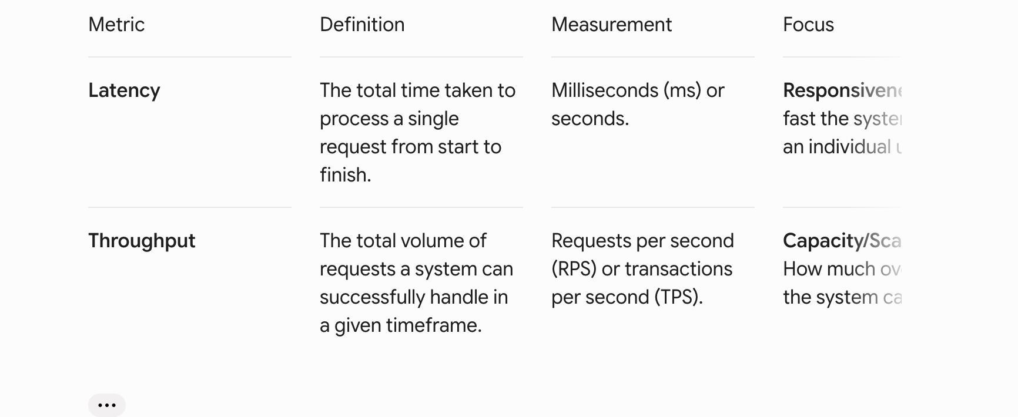

Goal is to ensure responsiveness at scalability

Term | Stands For | Definition | Example
SLA | Service Level Agreement | The external, legally binding promise made to customers regarding uptime and performance. Failing this often results in financial penalties. | "We guarantee 99.9% uptime per month."
SLO | Service Level Objective | The internal, stricter target set by the engineering team to ensure the SLA is met with a safe buffer. | "Internal goal: 95% of requests must process in under 300 ms."
SLI | Service Level Indicator | The actual, real-time measured performance of the system at any given moment. | "Currently, 93% of requests are processing under 300 ms." (Indicates the SLO is failing).

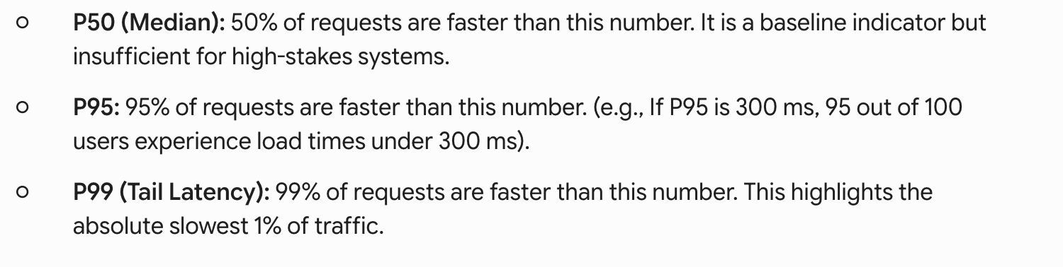
Load Testing: Applies expected, normal traffic to establish a baseline. Can the system handle what it was built for?
Stress Testing: Pushes the system beyond its intended limits. Does the system fail gracefully or crash entirely?
Spike Testing: Simulates sudden, massive bursts of traffic (like a flash sale or going viral). Can the system absorb the shock and recover?
Endurance (Soak) Testing: Subjects the system to a sustained load over a long period. Does the system suffer from memory leaks, database fatigue, or creeping slowdowns over time?

Caching Layer | Where It Lives | Primary Use Case | Examples / Tools
Client-Side | The user's device/browser | Offline support, speeding up navigation in Single-Page Applications (SPAs), reducing server round-trips. | Local Storage, IndexedDB, Service Workers.
CDN (Content Delivery Network) | Geographically distributed edge servers | Delivering static assets (images, CSS, JS) and sometimes API responses from a server physically closest to the user. | Cloudflare, AWS CloudFront.
Server-Side | Close to the application server | Storing frequently accessed, dynamic data like user sessions, auth tokens, or precomputed results. | Redis, Memcached.
Database-Level | Within or right next to the DB | Result-set caching: Storing the exact output of expensive, complex, or frequently run SQL queries (like heavy joins). | Native DB caching features.

